OUR LADY QUEEN OF PEACE CATHOLIC PRIMARY SCHOOL

POLICY FOR RELIGIOUS EDUCATION

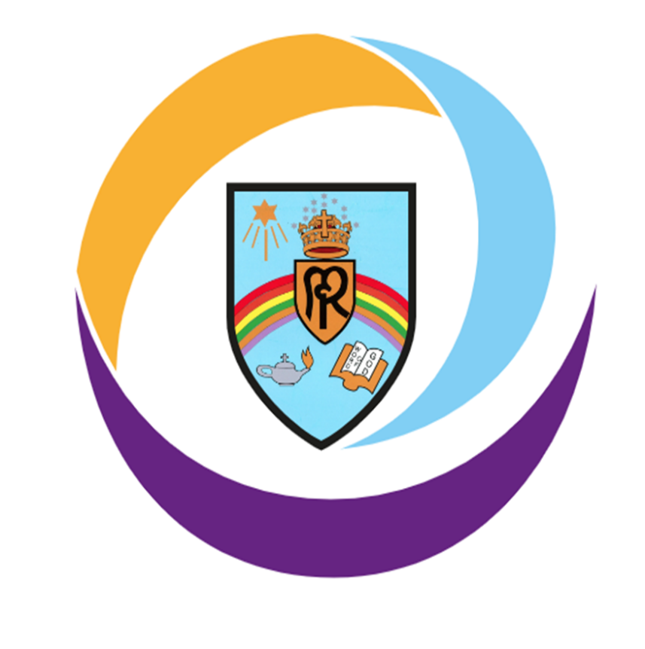

RE LINK GOVERNOR: Deacon Tony Hartshorn

INTERIM HEAD TEACHER: Mr Philip Wheelan

Reviewed: September 2024

**Mission Statement**

To Love and to Share, Believe and Achieve

At Our Lady Queen of Peace, we: LOVE each other as God has told us to do. SHARE our Catholic faith and love everyone.

BELIEVE that we can grow in God's love.

Take pride and celebrate all that we ACHIEVE together

# Our school is a caring school where we are ALL valued.

**Rationale of Religious Education**

The Bishop’s Conference of England and Wales (2000) stated:

*In the life of faith of the Catholic school, religious education plays a central and vital part. At the heart of Catholic education lays the Christian vision of the human person. This vision is expressed and explored in religious education. Therefore, religious education is never simply one subject among many, but the foundation of the entire educational process. The beliefs and values studied in Catholic religious education inspire and draw together every aspect of the life of a Catholic school. We are committed to classroom RE, then, because all pupils have the right to receive an overall religious education which will enable them, in the light of the faith of the Church, to engage with the deepest questions of life and find reasons for the hope which is within them (1Peter 3:15). Religious Education is, then, the core subject in a Catholic School.*

At Our Lady Queen of Peace Catholic Primary School Religious Education is central to the life of the school. The beliefs and values studied in RE inspire and draw together every aspect of the life of our school. To agree with the Bishops Conference, 10% of teaching time is devoted to RE. This will help to nurture the human wholeness of each pupil to play a full role in society and provide a community in which faith, culture and life are brought into harmony. R.E. is taught as a discrete subject but can also be part of cross-curricular work.

## Aims

* Recognise that everyone is created in the image and likeness of God.
* Foster, deepen and nurture the faith of pupils and staff.
* Promote an understanding and appreciation of Catholic teaching and practice.
* Educate and enrich each individual and develop values that reflect the gospel message and the teaching of the church.
* Foster and promote the moral and spiritual development of pupils.
* Promote and encourage active and committed participation and service in the life of the church and its community.
* Place Christ at the centre of our community.
* Develop a relationship with God by responding to the presence of God in their lives through prayer and reflection.
* Develop knowledge and understanding of the Catholic Faith in partnership with school, home and parish.
* Foster attitudes of respect and understanding for the beliefs and traditions of other faiths and of the global community.

## Our Religious Education Curriculum Policy seeks to …

* Promote high standards of teaching and learning in Religious Education.
* Foster an understanding of the Catholic Faith and its links to other Christian and world faiths.
* Recognise that each child is a unique individual able to make a valuable contribution to our school community and to the wider world.
* Encourage pupils to develop their individual skills to the best of their ability.
* Encourage pupils to develop an enquiring attitude to their own faith and that of others.

## How we meet our stated aims

* Children will, through a planned curriculum programme, learn about the Catholic faith and an appreciation of others in the world around them.
* Religious Education is taught as a subject in its own right, accounting for 10% of lesson time in each class timetable, using the ‘Learning and Growing as People of God’ curriculum supported by Birmingham Diocesan Education Service.
* The ‘Walk with Me’ programmes are used during Advent and Lent as part of class and whole school liturgies.
* At Our Lady Queen of Peace we aim to teach Religious Education through a multi-faceted approach. This might take the form of children working as a whole class, small groups, pairs or individuals, and encompassing a wide range of approaches, e.g. writing, investigations, role-play, discussion, meditation, prayer, music, dance.
* All pupils have access to the religious education provided irrespective of ability, gender, disability, colour or religion. Tasks are adapted or changed in order to accommodate all individuals. This would be included in planning.
* All pupils, whether Catholic, Christian or non-Christian, receive the same curriculum as Catholic pupils. They are fully integrated into the class structure and are given the same opportunities as non-Catholic pupils, e.g. GIFT Leaders, reading at Mass and saying prayers.
* The Assessment Foci follows a four year rolling programme based on the themes: The Liturgical Year, Scripture, The Sacraments and Living as Christians. These provide a tool as well as the National Age-Related Standards for RE, which pupils’ understanding and progression may be measured.
* Resources are available to staff for supporting a range of abilities. These are available to support the teaching of the Religious Education Programme. This includes materials for Collective Prayer & Liturgy, sacramental preparation, seasons and feasts of the church, Saints, multi-cultural themes and posters reflecting Old and New Testament events. The library also houses a number of child-centred books. All classes have a number of Bibles in their room.
* The use of technology is encouraged to enhance and develop the teaching and learning of Religious Education.
* Support is always available between colleagues at any time, e.g. in the planning of liturgy, induction for new staff and learning and teaching.
* The Religious Education Co-Ordinator attends termly Worcestershire partnership meetings as well as termly meetings as part of our SLA Diocese entitlement where different aspects of Religious Education teaching is discussed and good practice shared.

## Spiritual Development

* Pupils have the opportunity to experience different forms of prayer – formal, traditional prayers of the church and school day, spontaneous, meditative and reflective. Through prayer, we aim to develop a personal relationship with God. This will not just happen however, and we need to create the right atmosphere. Prayer time should be quality time and children should be taught in a meaningful way in order to develop a real ‘sense of prayer’. This may take place in whole school, key stage or class settings.

## Elements of Class Prayer

* **Listen to the Word of God:**

Use short passages of scripture from the Bible.

## Praise God:

Introduce a line from a Psalm, a Eucharistic Prayer.

## Meditation:

A quiet time for reflection is valuable for children of all ages.

## Intercession:

Children may suggest their own prayers or the teacher may initiate ideas.

## Thanks:

The Bible opened at a specific page can provide the stimulus.

## Sorrow:

Children need to recognise the need to repent, say sorry and reflect on things they have done wrong or have omitted to do.

## Formal Prayer:

Should be taught to classes in accordance with Diocesan Guidelines and the children therefore need to learn traditional prayer formulae. Pupils should be encouraged to understand why we say the prayer and what the prayer is about e.g. Stations of the Cross in Lent, the Rosary in October.

## Note: Daily class prayer time does not have to be lengthy and may only contain two or three of the above elements

* All classes have a focal point for prayer and religious artefacts with a display board in each classroom to support pupils in their prayer and worship.
* Formal/ whole school prayers include:

Morning prayer - ‘Father in Heaven’

Grace before meals – ‘Bless us O Lord’

Grace after meals – ‘Thank you God for the food we have eaten’

Afternoon – ‘God our Father’

Prayer and Liturgy takes place:

|  |  |
| --- | --- |
| Day | Focus |
| Monday | Whole School Gospel Liturgy |
| Tuesday | Fortnightly – Whole School Mass in Church, led by a particular Class  Fortnightly – Whole School Singing Praise and Liturgy |
| Wednesday | Phase Prayer and Liturgy (YR Y1 Y2, Y3 and Y4, Y5 and Y6) |
| Thursday | Key Stage 2 – Gifts of God Prayer and Liturgy  Reception and Key Stage 1 -  individual Class Prayer and Liturgy |
| Friday | Reception and Key Stage 1 – Gifts of God Prayer and Liturgy  Key Stage 2 -  individual Class Prayer and Liturgy |

* Class Prayer & Liturgy take place throughout the year.
* Pupils are encouraged to write their own prayers in various forms.
* The Liturgical Calendar plays a large part in the planning of collective worship and liturgy e.g. Holy Days of Obligation, Harvest, Advent, Christmas, Lent, Easter.
* Pupils in Year 3 are prepared for the Sacrament of Reconciliation and Holy Communion, while pupils in Year 6 are prepared for the Sacrament of Confirmation. This is very much a three-wayapproach between Parish, School and Family, enabling the children to appreciate and develop their understanding of the importance of their place in the community.

## Moral and Social Development

* The Religious Education curriculum underpins the moral development of pupils throughout their faith journey.
* Resources used and topics covered are founded on Catholic moral principles. Guidance may be sought from the Diocese and from the Parish Priest, as necessary.
* Pupils are encouraged to become mature and responsible Christians through such things as a Dojo point system and at other times when they can be praised and rewarded for their work, actions or attitude at our weekly achievement celebration and prayer.
* Social development is an on-going programme, incorporated into all curriculum areas, everyday experiences and teaching, showing pupils how to interact, accept and understand others as demonstrated through Catholic Social Teaching.
* Pupils are encouraged to be aware of the wider community by supporting and fund raising for charities including CAFOD, Operation Christmas Child, Father Hudson’s Home and Mission Together.
* Music, Art and Drama play an important role in the teaching of Religious Education and are used to enhance the pupils’ learning experiences.

## Multi-cultural Education

* Although Our Lady Queen of Peace is committed to handing on the Catholic faith and ethos, we do aim to enable pupils to learn Christian values to respect all people regardless of race, creed or skin colour.
* Through planned teaching undertaken by individual teachers, children are helped to learn about other cultures and people from other countries and learn to be responsible citizens in line with the fundamental British Values.
* Over their School life, children will learn elements of Judaism, Hinduism, Islam and Buddhism.

In this way, pupils are taught to be aware and respect other beliefs without compromising the principles of the Catholic faith.

## Management and Organisation

The subject leader has responsibility for the development of RE throughout the school.

* Policy writing
* Planning – ensuring that long term plans are reviewed in line with the SDP
* Evaluating and monitoring of teaching and learning in RE
* Reporting developments to the Head Teacher and the link governor
* Identifying training needs and informing staff of new developments
* Auditing resources
* Purchasing resources following consultation with staff

Class teachers are responsible for planning and providing engaging learning opportunities, using agreed long-term plans and implementing the Birmingham Diocesan Curriculum: Learning and Growing as the People of God. The Head Teacher is responsible for the implementation, monitoring and evaluation of the RE policy, teaching and learning and identifying training needs throughout the school. The link governor liaises with the subject leader. The Head Teacher reports to the governing body.

## Monitoring and Evaluation

Monitoring takes place in line with the school’s monitoring schedule. The policy document and curriculum planning are evaluated, and revised if necessary, in line with school development. The RE Lead monitors and evaluates the policy and teaching and learning and reports to the link governor.

**Home School Liaison**

At OLQP we value home school links and this is promoted through the completion of RE homework or projects, which give the opportunity for families to work together for the children to show their understanding of our faith. These might be linked to units being studied or sacramental and liturgical times of the year. There might also be opportunities for parents to join in RE lessons and ‘Stay & Read’ sessions dedicated to Scripture.