**Our Lady Queen of Peace**

**Catholic Primary School**

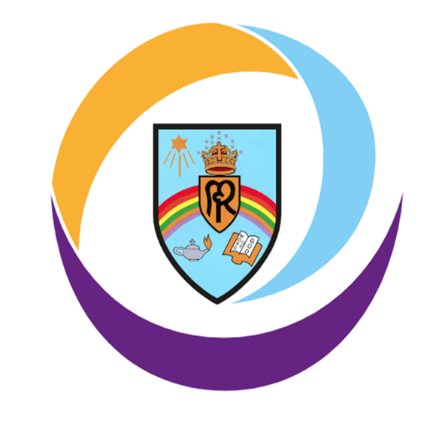

**Collective Prayer and Liturgy Policy**

|  |  |
| --- | --- |
| Created / Updated: | **September 2024**  Philip Wheelan  Interim Principal |
| To be reviewed: | September 2026 |

# The Nature of Collective Worship

At Our Lady Queen of Peace Catholic Primary School (OLQP) we believe that Christian worship in a Catholic school is concerned with giving glory, honour, praise and thanks to God. It is our loving response, in word and action, to God's invitation to enter into relationship, made possible through the work of Jesus Christ and the witness of the Holy Spirit.

# Legal Requirements

We acknowledge the legal requirement that there must be a daily act of worship for all pupils. This can take place at any time during the school day and can be either a single act of worship for all pupils, or separate acts of worship in school groups e.g. Key Stage assemblies. We understand that simply holding an assembly that includes a prayer, said either by the teacher or everyone present, does not fulfil this requirement. We also acknowledge that collective worship and assembly are distinct activities. They may sometimes form part of the same gathering, but the difference between the two will always be made clear.

The act of worship is not designated curriculum time under regulations and will not be subsumed under any part of the curriculum, including Religious Education. Assemblies, where teaching and learning take place, may be included as part of the RE curriculum on occasion.

At OLQP, responsibility for arranging a timetable of collective worship rests with the Governing Body in consultation with the Head Teacher.

# The Place of Collective Worship in the Life of our School

We endorse the belief that prayer and liturgy considers the religious and educational needs of all who share in it:

• Those who form part of the worshipping community in Church;

• Those for whom school may be their first and only experience of Church;

• Those from other Christian traditions, or none;

• Those from other faith backgrounds. It will be an educational activity or experience to which all can contribute and from which all can gain.

Prayer and liturgy in OLQP is an integral part of school life and central to the Catholic tradition.

# The Aims of Collective Worship

We believe that prayer and liturgy in our school community will provide a variety of opportunities to deepen our relationships with God and develop the following:

• contemplate the mystery of God;

• unite our worshipping Eucharistic community;

• develop the necessary skills of reverence, contemplation, reflection, interpretation, empathy, meditation which will enable our relationships with God to be deepened.

Full participation in our faith will allow us:

• To grow in spiritual, moral, cultural and liturgical understanding;

• To grow in understanding of our living faith tradition;

• To develop a sense of awe, wonder and inspiration in the person of Christ;

• To examine and reflect upon our own individual faith journeys;

• To develop the skills of prayer.

# 

# Implementation

All acts of worship should: -

• Give glory and praise to God;

• Be structured to ensure a quality experience for all participants;

• Be kept to the point (and brief wherever possible);

• Be clear in their liturgical focus and varied in their delivery;

Prayer and liturgy in our school may follow the pattern or variation of the pattern detailed below:

Gather - how we come together, the setting, the environment (quiet/ reflective music, lighted candles, statues, sat in a different format, sign of the cross, focus and examination of conscience etc);

Listen - a reading from the Scriptures, breaking the word, time to reflect on this and prayers to fit into the theme;

Respond - reflection time, prayer, discussion around the theme of the Scripture, silence or hymns.

Go forth (mission) - the sending out from the celebration, giving the children something to hold onto from the experience of the liturgy that they can take into their daily lives.

Prayer and Liturgy takes place:

|  |  |
| --- | --- |
| Day | Focus |
| Monday | Whole School Gospel Liturgy |
| Tuesday | Fortnightly – Whole School Mass in Church, led by a particular Class  Fortnightly – Whole School Singing Prayer and Liturgy |
| Wednesday | Phase Prayer and Liturgy (YR Y1 Y2, Y3 and Y4, Y5 and Y6) |
| Thursday | Key Stage 2 – Gifts of God Prayer and Liturgy  Reception and Key Stage 1 - individual Class Prayer and Liturgy |
| Friday | Reception and Key Stage 1 – Gifts of God Prayer and Liturgy  Key Stage 2 - individual Class Prayer and Liturgy |

Throughout the year each class is involved in planning and leading regular liturgies and Masses.

Collective worship will also be celebrated through:

* Daily class prayers at the beginning and end of the day and before and after lunchtime
* Whole school Mass
* Whole school Mass on Holy Days that fall within the school term
* School led celebrations in church e.g. Harvest Festival and Candlelight Service
* Advent and Lent reflections
* Liturgical presentations such as Nativity, Passion Play.

**Class Saints**

As a reminder that we are called to be saints and live a life of holiness, each class has a class saint to inspire them on their journey in faith.

The children learn about their class saint's life, why they are a good role model and how, through their example, we might become closer to Christ ourselves.  This gives our children the opportunity to know about the life and work of a variety of saints during their time at OLQP.

Reception – St Mary

Year 1 – St Joseph

Year 2 – St John Bosco

Year 3 - St Teresa of Calcutta

Year 4 – St Josephine Bakhita

Year 5 – Blessed Carlo Acutis

Year 6 – St Maximillian Kolbe

# The Planning, Content and Delivery of Collective Worship

Collective Worship is planned:

* following a structure with reference to the Liturgical Calendar, significant dates and the scripture will be the focus in most acts ofworship
* involving consultation with appropriate parties and reference to school aims and policies
* with flexibility to respond to changing situations within the class, school and the wider community
* to develop in pupils’ skills that enable them to prepare, organise and lead worship (See Appendix 1)
* to mark significant events such as a silent reflection on Armistice Day
* to give praise to God through art, dance, music and prayer
* to encourage the active participation of all

**Celebration of the Eucharist**

This takes place fortnightly for the whole school in Church and for holy or

celebratory days when within term time. Parents and parishioners are welcome

to attend these Masses and the dates are shared with parents, and on the Parish newsletter. Children taking part in the liturgy are well prepared by practising in advance

in school and supported by their parents at home. At these Masses children have the opportunity to take part in liturgy, offertory, altar serving and singing.

# The Catholic Curriculum

# Through the development of a Catholic Curriculum all staff have the knowledge and understanding of the Catholic Social Teaching themes. Staff ensure that through the Prayer and Liturgy there are opportunities for the pupils to develop their own knowledge and understanding of the key principles of the Catholic Social Teaching themes. Pupils are also encouraged to use this gained understanding to make age-appropriate links to their everyday lives and the world around them. The CAFOD resources are used to support this learning and it is also enhanced through trips, visitors to school and experiential days as well as involvement in charitable organisations.

# The Catholic School Pupil Profile is also linked to the Catholic Curriculum and the appropriate virtues are chosen and celebrated through the Prayer and Liturgy. The virtues are:

# • Grateful & Generous

# • Attentive & Discerning

# • Compassionate & Loving

# • Faith-filled & Hopeful

# • Eloquent & Truthful

# • Learned & Wise

# • Curious & Active

# • Intentional & Prophetic

# Recording

Collective Worship is recorded through written reflections, collections of pupils' contributions, prayers, tweets and children’s work. Each Class has a Prayer and Liturgy folder which contain pupil evaluations (as a leader of liturgy and a participant Appendix 2 and 3).

# Monitoring and Evaluation

The following will be monitored:

• Time set aside for prayer and liturgy;

• Whether the observed practice is consistent with agreed policy;

• Whether prayer and liturgy is resourced in terms of materials, visual aids etc;

• Staff development on prayer and liturgy and its impact;

• Prayer focus and its effectiveness in drawing pupils into prayer;

• Impact on pupils and members of the school community;

• Opportunities for pupils to develop the necessary skills to access worship and prayer;

# Resources

Each class teacher is responsible for maintaining a class RE display and prayer area linked to the unit of work and liturgical calendar. Pupils have access to a Class Prayer and Liturgy box from which they can choose appropriate resources to plan and lead worship.

The Headteacher and RE Coordinator are responsible for providing training and support to enable teachers and pupils to plan and lead meaningful collective worship.

**Appendix 1**

**Children Leading Collective Prayer and Liturgy Progression**

Teachers need to prepare and lead most Acts of Worship and be an excellent role model for children to emulate. Teachers should withdraw input gradually at the appropriate time depending on the age and stage of development of the children. Children leading worship should never detract from it being an enriching experience where glory, honour and praise is given to God.

# KEY STAGE ONE

At this stage, in most acts of worship the teacher will lead and model collective prayer and liturgy. At this age, children are facilitating worship rather than leading it. They may lead certain parts/elements.

## Reception

Children may

* Sing a gather song
* Make the Sign of the Cross
* Choose artefacts from a limited selection
* Greet everyone
* Set up Prayer table
* Lead prayers
* Say what they want to pray for

## Year 1

As Reception plus

* Choose artefacts from a wider selection
* Given the theme, choose an appropriate way to gather or go forth from a limited selection - Teacher to help

## Year 2

As Year 1 plus

* Can explain the purpose, theme and focus of the Collective Worship
* From a selection, choose one suitable element (Gather, Listen, Respond & Go forth) for the Collective Worship

# KEY STAGE TWO

In Key Stage 2, teachers still need to show the children how to prepare and deliver Collective prayer and liturgy. Teachers and pupils work together at first to prepare the collective act. Teachers gradually withdraw support allowing pupils to take more of a lead. Teachers should provide themes and scripture and oversee the children’s efforts before delivery.

## Years 3 & 4

All of Year 2 plus…

* Provide a suitable focus. They understand their choice and make appropriate use of Liturgical colours. - Lead singing
* Work ICT equipment
* Write prayers and petitions that fit the theme of the Collective Worship.
* Choose suitable ways to Gather, Listen, Respond and Go Forth

## Years 5 & 6

All of Years 3 & 4 plus…

* Given a set theme can now select appropriate Scripture passages (initially from a limited selection)
* By the end of Y6, pupils should be able to develop all parts of Collective Worship independently with understanding when given a theme or a passage from the scripture.

**Appendix 2**

**Evaluation of Prayer and Liturgy (Participant YR / KS1 and KS2)**

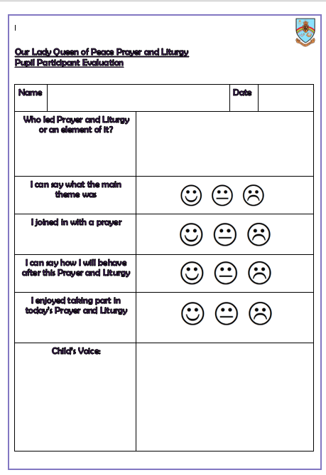

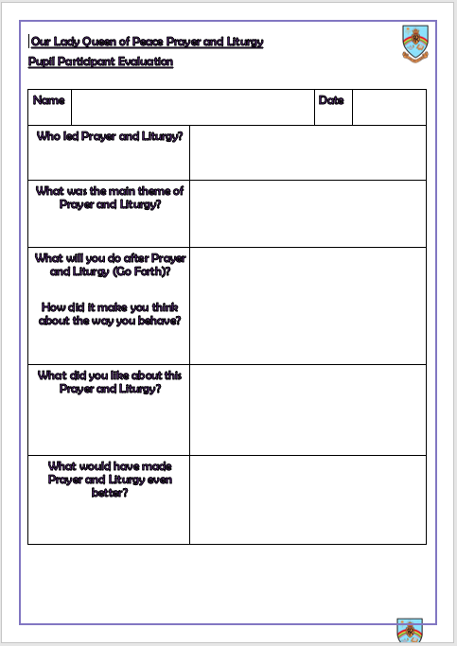

**Appendix 3**

**Evaluation of Prayer and Liturgy (Leader YR / KS1 and KS2)**

